Notes of files in Harvard RCE

Hospitalization data (1999-2016)

Location:
shared_space/ci3_health_data/medicare/gen_admission/1999_2016/targeted_conditions/

den-1999-2016-03-09-2019.csv: Patient summary file in csv format (67 GB)
med-1999-2016-03-09-2019.csv: Inpatient admission file in csv format (37.5 GB)

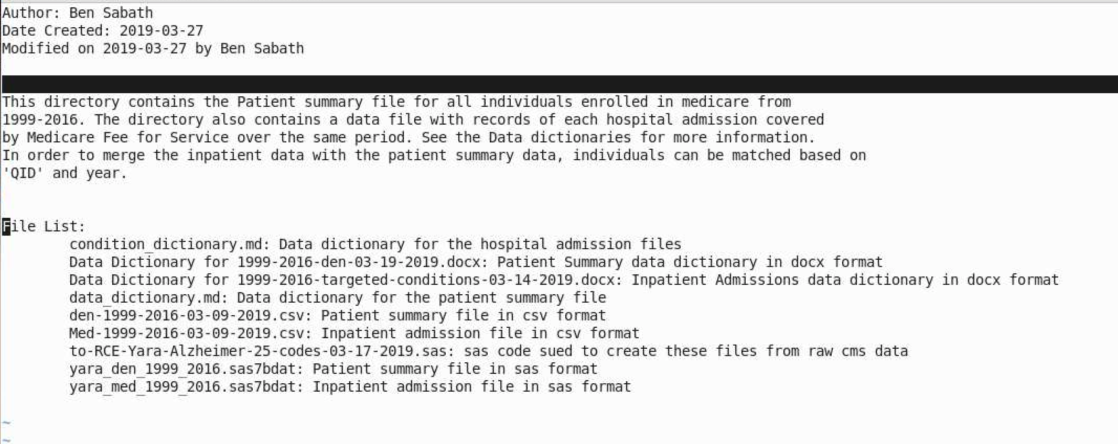

Data dictionary

162 million inpatient records

Data Dictionary for 1999-2016-targeted-conditions-03-14-2019.docx: Summary of contents

ICD9 codes from J Bobb’s paper

Location:
shared_space/ci3_analysis/jbobb_heat_wave_2014/

CCS-single-10-30-2013.txt (1MB)

